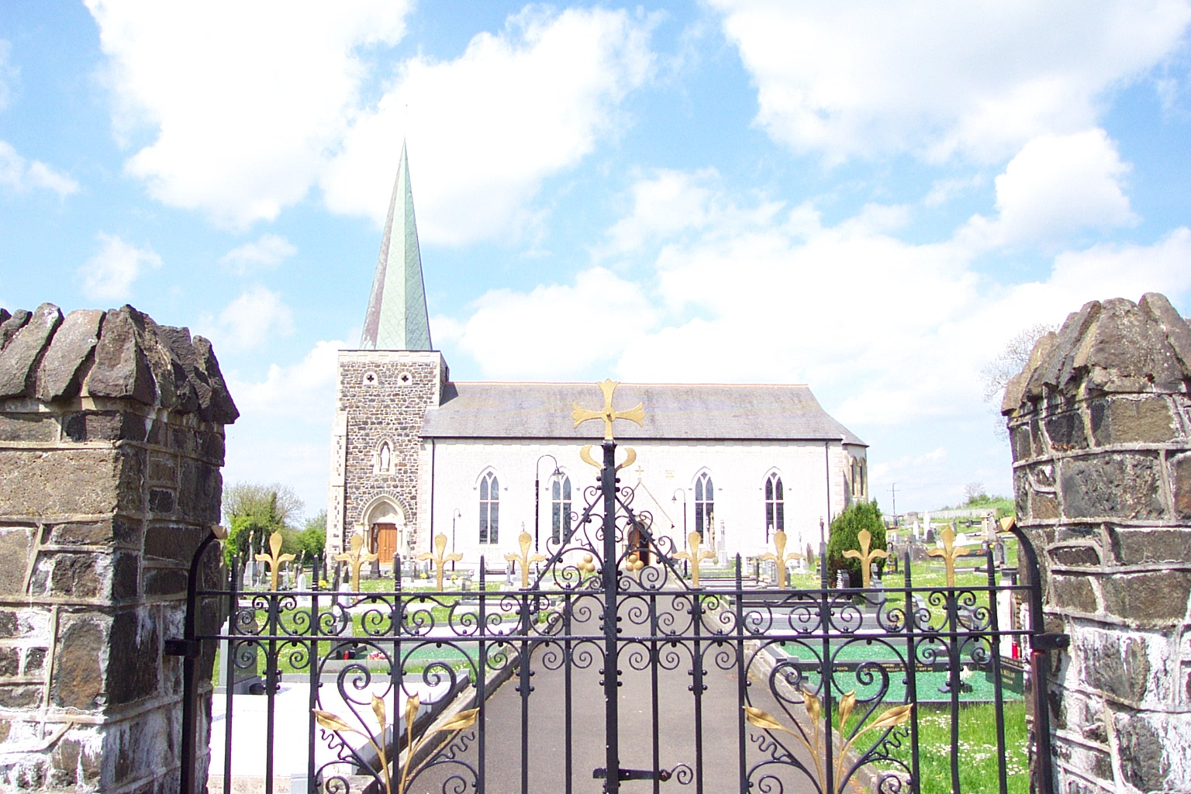
Very Rev. J Murray
Parochial House
9 Gortahar Road
Rasharkin
Co. Antrim
BT44 8SB

Tel/Fax 028 2957 1787

ST. MARY’S PARISH

Rasharkin
PARISH RECORDS

This information is solely for the purpose of updating the Parish Records. It will be treated as confidential
Family Name: | Murphy
Address: | House No: | 100
 | Road/Street: | Main Road
 | Town: | Anytown
 | Postcode: | BT73 29T
 | Phone Number: | 028 1111 2222
 | Email Address: | maryjoe@samplemail.com
Householder: | Title (Mr, Mrs, Miss etc): | Mr
 | Forename(s): | Joseph
 | Occupation: | Plumber
 | Date of birth (Optional): | 20/01/58
Family Members: |  | If there is only one parishioner in the house this section is not applicable.  If there are more than one person in the house, and they are not related, please continue to Additional Occupants section
Title | Names | Relation to Householder | Occupation  (or School/College attended) | Date of Birth (optional if over 18)
Mrs | Mary Murphy | Wife | Housewife
Miss | Anne Murphy | Daughter | Civil Servant | 19/03/82
Mr | Sean Murphy | Son | Jordanstown | 10/02/84
 | Brigid Murphy | Daughter | Our Lady of Lourdes | 11/06/90
 |   Brian Murphy | Son | St Patrick’s PS | 11/05/94
Mrs | Hanna Kelly | Mother-in-law | Retired Nurse

Additional Occupants:
Title | Full Name |  | Occupation  (or School/College attended) | Date of Birth (optional if over 18)
Mr | Jim Begley |  | Trainee Electrician | 15/3/85

Date form completed: | 2nd March 2005
* Gift Aid can be claimed by the parish on contributions made by parishioners who are earning a wage and paying tax. If you have any queries to your eligibility to register for Gift Aid, please contact the parish office. A Gift Aid Declaration Form can be downloaded on the Parish Website

